

AMENDMENT NUMBER 43 TO THE OFFICIAL PLAN OF THE URBAN AREA OF THE CITY OF CLARENCE-ROCKLAND
Lot 25, Concession 1 (Old Survey), Part 2 on Plan 50R-2365
Prepared by the Community Development Department of the City of Clarence-Rockland
1560 Laurier Street Rockland (Ontario) K4K 1P7
(613) 446-6022
June 2026
Contents:
PART A – PREAMBLE – does not constitute part of this amendment.
PART B – AMENDMENT – consists of the following text and map (designated as Schedule “A”); it constitutes Amendment No. 43 to the Official Plan of the Urban Area of the City of Clarence-Rockland.
PART C – APPENDICES - does not constitute part of this amendment. These appendices contain the background information and information about the public involvement associated with this amendment.

PART A - THE PREAMBLE

(This section does not form part of the Amendment but provides background information and the rationale for the Amendment.)

Purpose
The purpose of this amendment is to modify the land use designation of the subject properties from “Low Density Residential” to “Medium Density Residential”.

Land affected
The subject land is described as Part of Lot 25, Concession 1 (Old Survey), Part 2 on Plan 50R-2365, municipally known as a vacant land on Roger Street

Basis
The property is currently within the Urban Area and designated “Low Density Residential” in the Official Plan.
This amendment will change the designation to “Medium Density Residential” to permit the development of 74 units of townhouses and low-rise apartment dwellings.

PART B - THE AMENDMENT
(This section forms part of the Amendment.)

Introductory Statement
All of this part of this document, entitled PART B - THE AMENDMENT, consisting of the following text and the attached map designated as Schedule “A”, constitutes Amendment No. 43 to the Official Plan of the Urban Area of the City of Clarence-Rockland.

Details of the amendment
The Official Plan of the Urban Area of the City of Clarence-Rockland is amended as follows:
Item 1: Schedule “A” – Land Use and Constraints of the Official Plan is hereby amended by changing the land use designation of the part of the land described as Lot 25, Concession 1 (Old Survey), Part 2 on Plan 50R-2365 from “Low Density Residential” to “Medium Density Residential”.

Implementation and interpretation
The implementation and interpretation of this amendment shall be in accordance with all other relevant policies of the Official Plan of the Urban Area of the City of Clarence-Rockland.

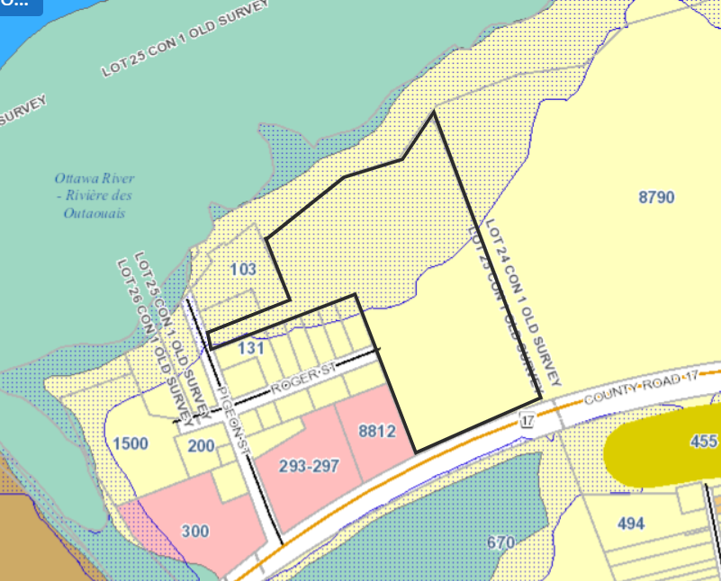
Schedule “A”
From Low Density Residential to Medium Density Residential

PART C – APPENDICES
(This section does not form part of the Amendment.)

APPENDIX I: Excerpt of City of Clarence-Rockland Base Map Showing Affected Land
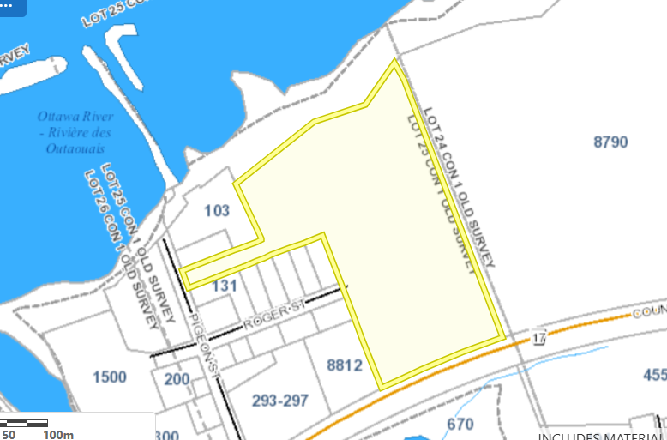

APPENDIX II: Notice of Public Meeting

