The Corporation of the City of Clarence-Rockland

By-law 2023-XX

Being a By-law to amend Zoning By-law No. 2016-10.
Whereas Zoning By-Law no. 2016-10 regulates the use of land, and the use and erection of buildings and structures in the City of Clarence-Rockland; and
Whereas the Council of the Corporation of the City of Clarence-Rockland considers appropriate to amend Zoning By-Law No. 2016-10, as described;
Now therefore, the Council of the Corporation of the City of Clarence-Rockland enacts as follows:
- The property described as 2187 Nolan, Part of Lot 9, Concession 10, and identified on Schedule “A” attached to and forming part of this by-law shall be the lot affected by this by-law.
- Map “A” of Zoning By-Law No. 2016-10 is hereby amended by changing the zoning category of the subject property from “Agriculture (AG) Zone” to “Agriculture-Exception 28 (AG-28) Zone” for the retained parcel of consent file D-10-22-21 as identified on Schedule “A” of the map attached hereto and fully integrated as part of this By-law.
- Section 12.1.3 is amended by modifying subsection (bb) to read as follows:
“(bb) AG-28, Part of Lot 9, Concession 10 (retained parcel of consent D-10-22-21).
Notwithstanding the provisions of this By-law to the contrary, the lands zoned AG-28 shall be used in accordance with the following provisions:
    - Residential uses are prohibited
    - Minimum lot area 17 hectares
- This By-law shall become effective on the date of passing hereof, subject to the approval of the Tribunal or following the last date for filling objections as the case may be.
- Read, passed and adopted in open council this XX day of July 2023.

Mario Zanth, Mayor Monique Ouellet, Clerk
Explanatory Note

Purpose and Effects of this By-Law
The purpose of the by-law is to amend Zoning By-Law No. 2016-10 in order to change the zoning category of the subject property from “Agriculture (AG) Zone” to “Agriculture-Exception 28 (AG-28) Zone” for the retained parcel of consent D-10-22-21 (the farmland) in order prohibit residential uses and allow an agricultural lot with a minimum lot area of 17 hectares in order to fulfill a requirement of severance file D-10-22-21.
For further information concerning the amendment to Zoning By-Law No. 2016-10, you may contact the Community Development Department, at the Town Hall, 1560 Laurier Street or by telephone at (613) 446-6022.

Schedule A to By-law 2023-XX

Certificate of Authentication
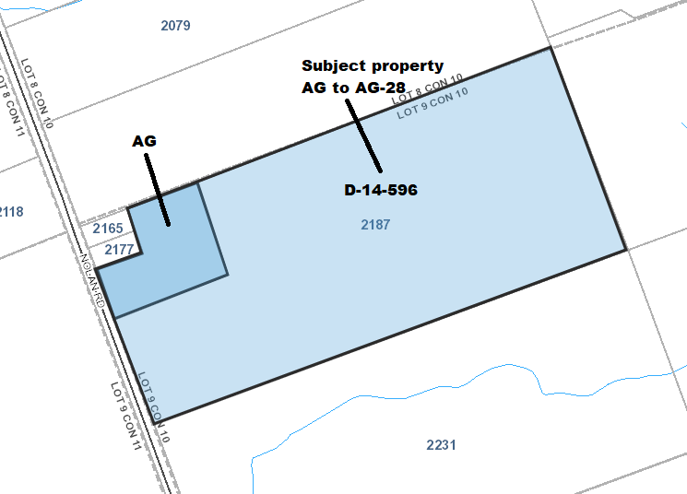

Zone change from AG to AG-28
Not to scale
This is plan Schedule A to Zoning By-Law 2023-XX, passed the XX day of July, 2023
2187 Nolan Road, Part of Lot 9, Concession 10
Prepared by the City of Clarence-Rockland
1560, Laurier Street, Rockland, Ontario K4K 1P7

Mario Zanth, Mayor

Monique Ouellet, Clerk

